

报告题目: TU Delft and ICT Research
报告人 : Prof. Jan van Katwijk and Prof. Hans Tonino
时 间：4月3日(周一) 上午9:30-12:00
地 点：中科院计算所400教室
Abstract：
TU Delft is one of the leading technical universities in Europe. According to the ranking of the Times Higher Education Supplement it can be ranked within the 15 best technical universities of the world. This report will tell us some aspects as follows.
First, the report will briefly introduce the university, zooming in onto the faculty Electrical Engineering, Mathematics and Computer Science.
Second, the report will introduce the TU Delft ICT Research Center. The ICT Research Center encompasses all research in ICT within the university. About 400 researchers in 4 faculties are working in the field of ICT, ranging from micro electronics and antenne design to human perception issues, participating in local, national and international consortia.
Thirdly, the research of TU Delft ICT Research Center especially the ICIS program(Interactive Collaborative Information Systems) will be presented detailedly.
The ICS project , a 27ME project was started by the Center and together with other partners. Key to the ICIS project is that daily interactions between information systems and user drive the quest for more intelligent information systems that can operate in a chaotic world and can match and complement the intelligence of the humans-in-the-loop. The ICIS partners believe that the search for techniques and methods that help to build information systems with intelligent behaviour is one of the most critical areas in future information systems research. In particular ICIS application domains are characterized by: Real-time decision making in complex, dynamic and chaotic environments.
Finally, the report will tell us the master programmes in computer science offered by the faculty of EEMCS. You may also get something you want to know about studying in TU Delft here.
欢迎光临!
计算所位置：
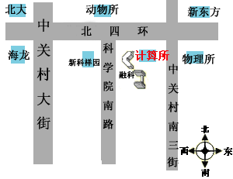
联系人：陈 明
电 话：010-62565533-5689
Email： chenm@ics.ict.ac.cn

