Science Magazine 1 July, 2005
http://www.sciencemag.org/sciext/125th/
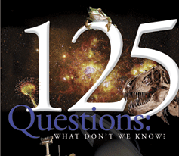

THE QUESTIONS ： The Top 25
Essays by our news staff on 25 big questions facing science over the next quarter-century.
> What Is the Universe Made Of?
> What is the Biological Basis of Consciousness?
> Why Do Humans Have So Few Genes?
> To What Extent Are Genetic Variation and Personal Health Linked?
> Can the Laws of Physics Be Unified?
> How Much Can Human Life Span Be Extended?
> What Controls Organ Regeneration?
> How Can a Skin Cell Become a Nerve Cell?
> How Does a Single Somatic Cell Become a Whole Plant?
> How Does Earth's Interior Work?
> Are We Alone in the Universe?
> How and Where Did Life on Earth Arise?
> What Determines Species Diversity?
> What Genetic Changes Made Us Uniquely Human?
> How Are Memories Stored and Retrieved?
> How Did Cooperative Behavior Evolve?
> How Will Big Pictures Emerge from a Sea of Biological Data?
> How Far Can We Push Chemical Self-Assembly?
> What Are the Limits of Conventional Computing?
> Can We Selectively Shut Off Immune Responses?
> Do Deeper Principles Underlie Quantum Uncertainty and Nonlocality?
> Is an Effective HIV Vaccine Feasible?
> How Hot Will the Greenhouse World Be?
> What Can Replace Cheap Oil -- and When?
> Will Malthus Continue to Be Wrong?
So Much More to Know . . .
A roundup of 100 additional problems that should keep researchers busy for years to come.

